**MOHIT PARAG APTE FINLATICS PROJECT 1**

**Identify the root problem and use the MECE (mutually exclusive, comprehensively exhaustive) principle, discussed already in the module videos, to break down the problem**

We know that the company sells pre-made software and applications for companies. The three products they offer are DevOps bundle, cybersecurity and digital marketing. However, 90% of the income comes from the digital marketing product. This would mean that DevOps bundle and cybersecurity products are not selling as much. They are not up to the mark. This is where the main problem lies.

MECE (mutually exclusive, comprehensively exhaustive) Principle:

1. Manufacturing
   1. The product may be of a lower quality compared to the competitors.
   2. The workers may not be skilled up to the mark in the technology of DevOps and cybersecurity
   3. The infrastructure provided to the workers may be incomplete.
   4. Low finances may have resulted in unskilled workers
   5. Unproductive workforce may be higher.
2. Marketing
   1. The countries in which the product is sold might be saturated
   2. The marketing of the product may not be reaching the target audience
   3. The marketing team may not be able to explain the product to the consumer
3. Delivery
   1. The maintenance work may not be done properly resulting in lower rating of the product.
   2. The maintenance team might be unskilled to take care of the consumer difficulties

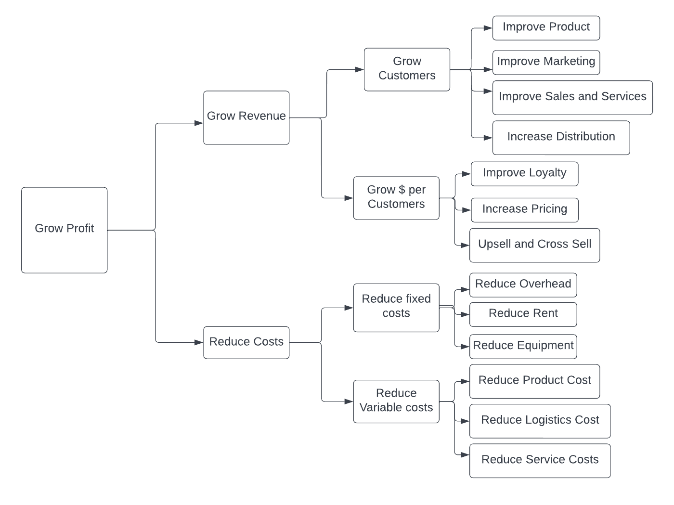**Using the profitability tree down structure, divide it in two parts ‘Revenue’ and ‘Cost’.**

**The company is looking forward to investing in India, US and Europe. See the potential growth for different sectors in these geographical locations.**

According to the data the company has more profit margins in Europe and US. The company has very low margins in India. The cost of production and labour is very low in India while the cost of production is very high in Europe and US.

Hence the company needs to increase its production in India at a lower cost and cheap labour and then sell it and market it in Europe and US so that the profit margin will be higher.

The growth in India be considered by increasing the consumer base at a lower profit margin. Since the population is large, even though there is a low profit margin, the number of software sold will be much higher and thus the profit will be approximately same as that of US and Europe.

**In the US and Europe, the healthcare sector seems promising and the same for India with the BFSI sector. Explore other options and see what could be done differently.**

The company needs to expand it’s business by approaching small hospitals and pharmaceutical industries to increase their customer base.

In the same way, in India, company should approach rural banks and co-operative banks to increase their consumer base.

They should also explore other continents like South Africa and Brazil where the economy is growing.

**Finally, provide recommendations for where the company should invest and what kind of acquisitions it should do.**

The company should acquire smaller companies specialised in Cybersecurity and Dev-Ops in order to increase their profit margins. They should also increase their business in developing countries like Brazil and South Africa in order to increase the profits.

They should also try to hire more skilled workers in order to make their product exclusive. They should consult and hire marketing experts so that the product reaches in various other continents.

Thank You